Upload Attendance into CloudCME
Sign into CloudCME at https://mainehealth.cloud-cme.com
Scroll to the bottom of the homepage and click on the Administration link
Then, in the blue left-hand navigation panel, click on Activities and then Record Attendance
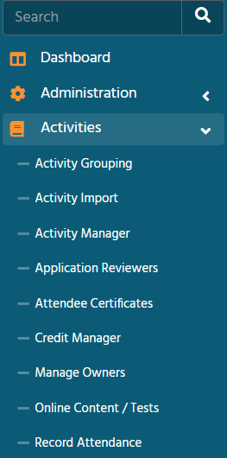
In the open text box, type in the name of the activity (if it is an RSS, there will be multiple activity names with different dates to choose from). If there is already a list of names, but Hours Claimed in Credit Details column is 0, click on the box to the left of each name in attendance to highlight them and then click the blue Save Credits button above the search box.
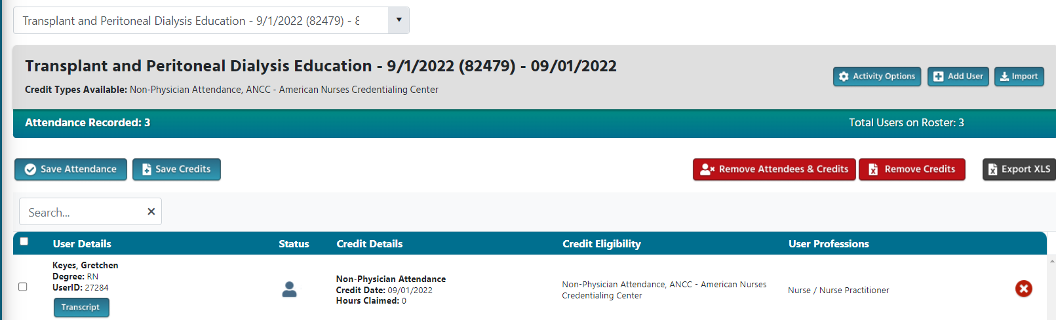

If there are no attendees listed or an attendees is not listed, you can add individual attendees or by importing a list.
To add an individual, click on the blue Add User button and type in their last name in the Search for Existing User box and then click on their name. If they are not listed, you will need to fill out the Create New CloudCME User section. Once you find/create them, click the black Add User & Award Credit button.
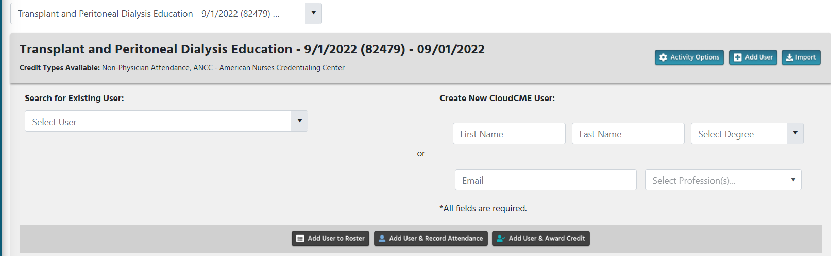
To import a list of attendees, you must use the upload template that is provided. Fill in the template and save it. Then click on the blue Import button and then Select files and once you select a file to upload it will open for you to show the list.
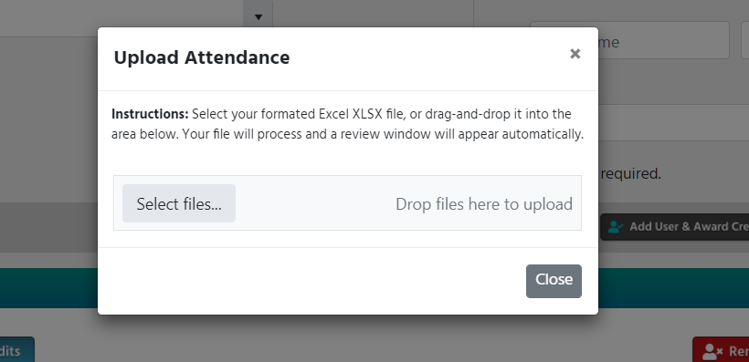
If you have any questions, please email cloudcmehelp@mainehealth.org

